**EXPRIMENT – 7**

**SQL query based on DML**

1. **Change salary of employee 115 to 8000 if the existing salary is less than 6000.**

UPDATE employees

SET salary = 8000

WHERE employee_id = 115 AND salary < 6000;





1. **Change job ID of employee 110 to IT_PROG if the employee belongs to department 10 and the existing job ID does not start with IT.**

UPDATE employees

SET job_id = 'IT_PROG'

WHERE employee_id = 110

AND department_id = 10

AND job_id NOT LIKE 'IT%'**;**

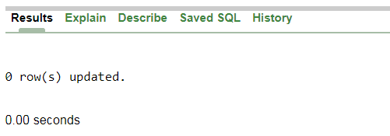

1. **Insert a row into departments table with manager ID 120 and location ID in any location ID for city Tokyo.**

INSERT INTO departments (department_id, department_name, manager_id, location_id)

VALUES (125, 'New',120,(

SELECT location_id

FROM locations

WHERE city = 'Tokyo') );

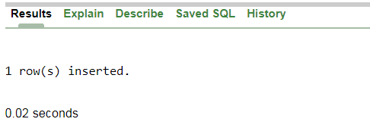

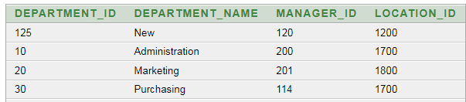

1. **Insert a new employee into employees with all the required details.**

INSERT INTO employees ( employee_id, first_name, last_name, email, phone_number,

hire_date, job_id, salary, commission_pct, manager_id,

department_id)

VALUES ( 123, 'John’, 'Doe', 'johndo’, '555-1234' SYSDATE, 'SA_REP' 5000, 0.1,

101, 30);





1. **Delete department 20.**

DELETE FROM departments

WHERE department_id = 20;

